CSS Inheritance

*(First download task 2 folder containing the web-page and resources.)*

Pretend it is your first day working for a web development company, your boss has just come into your office and handed you a website to fix for a client. The client has given you a picture of what he/she wants the webpage to look like. *(see image 1 below)*.

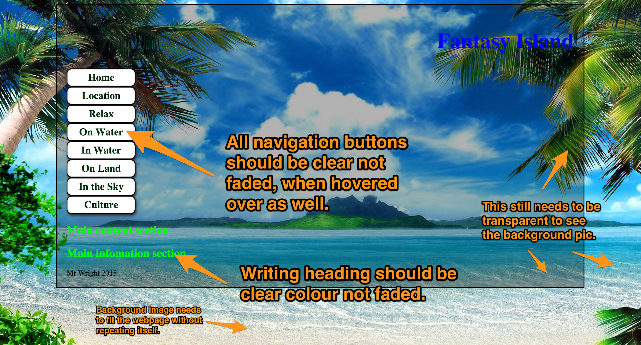

Find out how to fix the problems, by going online to CSS pages etc.

Remember your boss is counting on you to find the solution!

Tasks

1. Take a screenshot of your web-page, after you have found the answer and have fixed it.
2. What was the problem? Why were the navigations buttons text and heading faded?

|  |
| --- |
|  |